Contact Information

Today’s Date:

Full names:

Address:

Phone:

Email:

Personal information

Date of birth:

Emergency contact number:

History

Family members:

Medical issues:

Trauma:

Addictions:

Medications:

Previous therapy/coaching?

Other:

Primary Reason(s) for you visit?

Wheel of Life
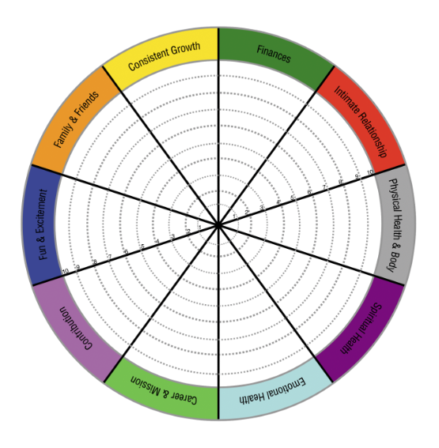

Primary Focus

Please identify one area of interest that you want to focus on with me as your coach.

Example:

Deal with a trauma

“I would like to develop better ways of coping with my traumatic feelings.”

Goals and Commitments

A goal is a specific activity or process you want to complete which is measurable i.e. “I will lose 10 pounds in 2 months” “I want to earn $10,000 more this year”. A commitment is a quality of life shift i.e. “I am committed to eating better and getting fit” “I am committed to earning more money this year”.

Goals Commitment

Health | 1 | Lose 10 pd in 2 months | I want to lose more weight
 | 2
Money | 1
 | 2
Friends and Family | 1
 | 2
Relationship | 1
 | 2
Personal Growth | 1 | Reduce anxious feelings from my trauma that disturb my family relationships | Reduce trauma
 | 2
Fun and Recreation | 1
 | 2
Physical Environment | 1
 | 2
Career | 1
 | 2

Daily Habits

Habits are positive actions you can take each day to achieve your goals. Based on the results of your Wheel of Life Exercise, what actions would help you move forward? I.e. spending 20 minutes a day exercising or taking a walk, breathing for a few minutes, talking with your kids without your cell phone etc.

- _____________________________________________________________________
- _____________________________________________________________________
- _____________________________________________________________________
- _____________________________________________________________________

Completion Log

Item to Complete Do By Done

Call a friend | Wed | check

LIFE COACHING AGREEMENT
Agreement between: name, company, address __________ (Coach – identify coaching qualifications, certificate, credential etc.) and ______ (Client) whereby Coach agrees to provide Coaching Services for Client focusing on the following topics/results/outcomes/goals attached to this agreement.
Description: Coaching is partnership (defined as an alliance, not a legal business partnership) between the Coach and the Client in a thought-provoking and creative process that inspires the client to maximize personal and professional potential.

Responsibilities:

1. Client is responsible for creating and implementing his/her own physical, mental and emotional well-being, decisions, choices, actions and results. As such, the Client agrees that the Coach is not and will not be liable for any actions or inaction, or for any direct or indirect result of any services provided by the Coach. Client understands coaching is not therapy and does not substitute for therapy if needed, and does not prevent, cure, or treat any mental disorder or medical disease.

2. Client understands that coaching is not to be used as a substitute for professional advice by legal, mental, medical or other qualified professionals and will seek independent professional guidance for such matters. If Client is currently under the care of a mental health professional, Coach will recommend that Client inform the mental health care provider.

3. Client agrees to communicate honestly, be open to feedback and assistance and create the time and energy to participate fully in the program.
Services: The parties agree to engage in a ___ month Coaching Program through (describe method(s), e.g., in-person, internet, telephone) meetings. Coach will be available to Client by e-mail and voicemail in between scheduled meetings as defined by the Coach (describe those terms here). Coach may also be available for additional time, per client’s request on a prorated basis rate of ________ (for example, reviewing documents, reading or writing reports, engaging in other client related services outside of coaching hours).
Schedule & Fees: This coaching agreement is valid as of 00/00/0000. The fee is ______ (amount in advance if applicable) and/or __________ (amount) per month based on (frequency of meetings such as # of meetings per/ wk, month, etc.).

The calls/meetings shall be ____________ (length of call or meeting for example 30, 45, 60, 90, 120 minutes). If rates change before this agreement has been signed and dated, the prevailing rates will apply.

Procedure: The time of the coaching meetings and/or location will be determined by Coach and Client based on a mutually agreed upon time. The Client will initiate all scheduled calls and will call the Coach at the following number for all scheduled meetings xxxxxx. If the Coach will be at any other number for a scheduled call, Client will be notified prior to the scheduled appointment time.

Confidentiality: This coaching relationship, as well as all information (documented or verbal) that the Client shares with the Coach as part of this relationship, is bound to confidentiality by the ICF Code of Ethics but is not considered a legally confidential relationship (like in Medicine or Law). The Coach agrees not to disclose any information pertaining to the Client without the Client’s written consent. The Coach will not disclose the Client’s name as a reference without the Client’s consent. Confidential information does not include information that: (a) was in the Coach’s possession prior to its being furnished by the Client; (b) is generally known to the public or in the Client’s industry; (c) is obtained by the Coach from a third party, without breach of any obligation to the Client; (d) is independently developed by the Coach without use of or reference to the Client’s confidential information; or (e) that the Coach is required by law to disclose.

Cancellation Policy: Client agrees that it is the Client's responsibility to notify the Coach ___ (number of) hours in advance of the scheduled calls/meetings. Coach reserves the right to bill Client for a missed meeting. Coach will attempt in good faith to reschedule the missed meeting.
Termination: Either the Client or the Coach may terminate this agreement at any time with _#__weeks written notice.
Limited Liability: Except as expressly provided in this agreement, the Coach makes no guarantees or warranties, express or implied. In no event will the Coach be liable to the Client for consequential or special damages. Notwithstanding any damages that the Client may incur, the Coach’s entire liability under this agreement, and the Client’s exclusive remedy, will be limited to the amount paid by the Client to the Coach under this agreement for all services rendered up until the termination date.
This is the entire agreement of the parties, and reflects a complete understanding of the parties with respect to the subject matter. This agreement supersedes all prior written and oral representations.
If a dispute arises out of this agreement that cannot be resolved by mutual consent, the Client and Coach agree to attempt to mediate in good faith for up to (certain amount of time such as 30 days) after notice given. If the dispute is not resolved, and in the event of legal action, the prevailing party shall be entitled to recover attorney’s fees and court costs from the other party.
Thank you!
Please sign both copies and return one copy of this Client Agreement prior to the first scheduled coaching meeting. Retain one copy for your records and mail the other to:

Client Name and Address

Signature: Date:

Coach Name and Address

Signature: Date:

