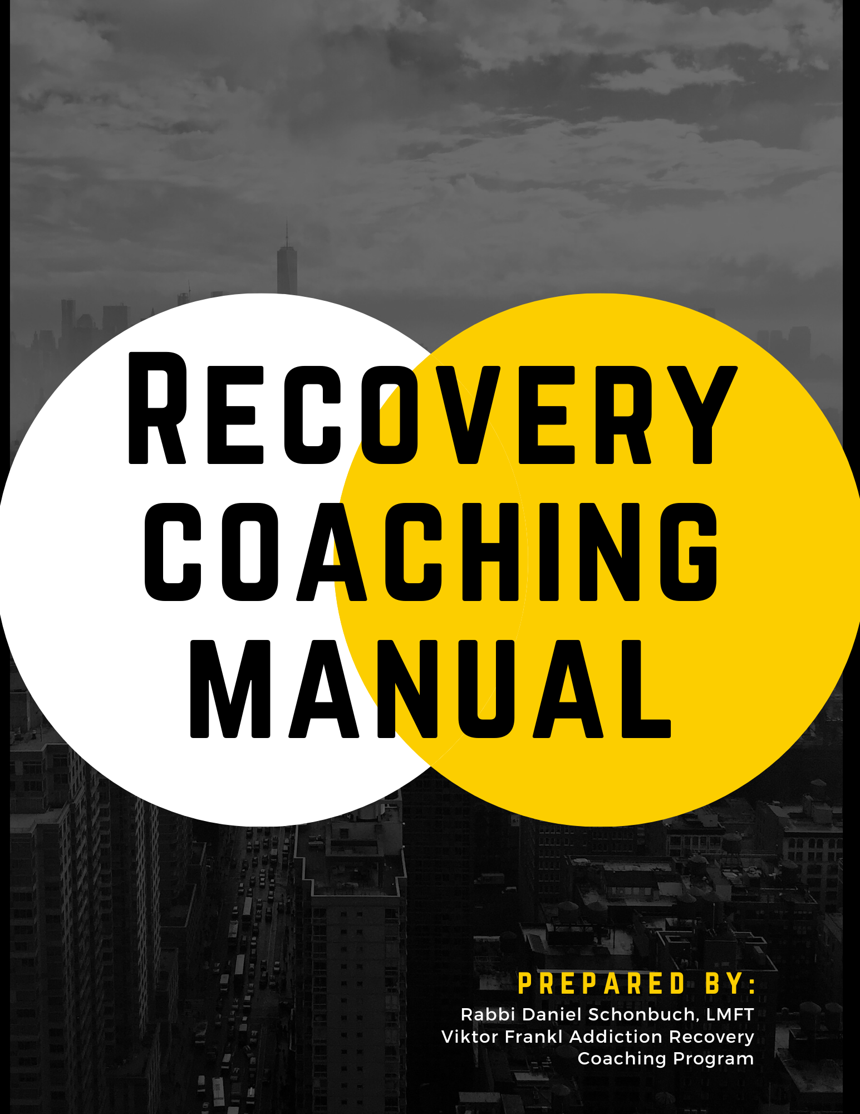

Table of Contents

Intake 3
Drug Use 8
Recovery Plan 13
Progress Notes 18

Intake

Last name_______________________________________________________________

First name_______________________________________________________________

Date of birth____________

Address__________________________________________________________________

Phone number_________________________

Emergency contact name, number and relationship________________________________

Medical conditions__________________________________________________________

Medication ________________________________________________________________

Diagnosis_________________________________________________________________

Tell me about yourself

What is your goal in coming to see me today?

What have you specifically already tried before yourself?

Who referred you?

How do you feel about being here today?

Angry, uncertain, helpful, resentful, reserve, happy, anxious, resign, excited, fearful, afraid, determined, scared, confused, ready

What would you like to accomplish?

Maintain sobriety, recovery support, anger management, become more spiritual, understand addiction, go to more AA meetings, get employment, improve relationships, improve life, understand recovery, get sponsor, prayer meditate, obtain housing, food and clothing, avoid jail, become a better person, change thinking, other.

Please list your most important goals in order of importance:

1 | 2 | 3 | 4
5 | 6 | 7 | 8

On a scale of 1 to 5 with 5 being very confident and 1 being not confident, how confident are you that you’ll be able to achieve each one of your goals listed?

1 | 2 | 3 | 4
5 | 6 | 7 | 8

On the same scale, how ready are you to start working on your goals today?

1 | 2 | 3 | 4
5 | 6 | 7 | 8

Please circle all that apply to you. If you have an emergency actuation need help, call 911

Not safe home, homeless, sexual abuse, suicidal, no food, special-needs, abuse, mental health, not safe and labor, risk of relapse, no medication, need medical attention.

Please circle anything that relates to your card employment status:

Are you employed, Laid off, quit job, looking for work, full-time student, someone supports you, can’t find work because of legal problems, part-time work, just got out of jail, like your job/don’t like your job, looking for a new job, My job is good for recovery, my job is bad for recovery, job affect my recovery.

Think of the skills you have.

List them in an order of what is your best from 1 to 8, 1 being your best, 8 being your worst

1 | 2 | 3 | 4
5 | 6 | 7 | 8

List eight skills that you would like to develop and get more experience.

1 | 2 | 3 | 4
5 | 6 | 7 | 8

What is your level of education?

Highschool diploma, didn’t finish high school, is yeshiva, seminary, college degree.

Please circle any item that you’re interested in getting help with.

Learn GED, return to school, academic counseling, getting into college, technical vocational training, applying to schools.

Please circle who you live with.

With family, homeless, with friends, and group home, alone, with spouse, others.

Have you ever been in legal trouble?

Never been arrested, convicted felon, misdemeanor, charges dropped, DUI, Perel, awaiting trial, other.

Please describe your mental health history below.

Mental health diagnosis? Have you ever been hospitalized because of mental health reasons, if yes where and why? Have you ever had detox complications? Are you prescribed any medication for mental health reasons? If yes, do you take them regularly as prescribed? Have you ever had treatment for addiction? If yes, where?

Circle the state in the best describes your current situation.

I don’t have an addiction problem, I’ve used in the last week, I haven’t used in one week, I want to stop and can’t stop, I’m in recovery and I’ve been drug and alcohol free for over one year, I’m in early recovery I’ve been clear and sober for 90 days, I’m actively using,“ order to stop.

Please answer the questions below as relate to you:

Do you have a recovery plan? Yes or no?

Do you want help to create a Recovery action plan? Yes or no?

What person do you look to when you need help?

Are you interested in working with a trained professional who can help you to reach recovery goals and solutions? Yes or no?

Here are some sober activities. Please list eight of your own.

Writing/poetry, walking, music, art, lifting weights, bowling, hiking, gardening,. Now list your own.

1 | 2 | 3 | 4
5 | 6 | 7 | 8

In each of the following categories, please describe your current situation, how much time is spent each week on it,, and what is your future goal?

Importance level (1-10) Weekly Hours Future Goal

Health

Wealth

Relationships

Family

Career/job

Spiritual

Play time

Circle any drug you may have used, and explain first and last use and if ever had a problem:

Alcohol

Barbiturates

Sleeping pills

Benzodiazepines

Caffeine

Cocaine

Crack

Ecstasy MDMA

Ephedra

Glue

Heroin or other inhalants

LSD

Marijuana

Methadone

Methamphetamine

Masculine

Mushrooms

Nicotine

Nitrous oxide

Opiate or pain pills

PCP

Peyote

Prescription drugs

Psilocybin

Quaaludes

Speedballs

Steroids

Other

Based on your choice of drugs or addiction, please answer the following questions:

How do you get started using or doing?
When you drink or drug, how much do you usually drink or drug?
How many drinks do you usually have per day or per week?
How much of a drug do you usually have per day or per week?
How have you ingested the drug?
What is the best thing about getting high?
What is your favorite thing to do when drinking/using drugs?
Other times you intend to use these substances less!
Are there any times you have you successfully stopped?
How much do you spend each week on your drugs or alcohol?
Do you usually drink/drugs alone or with others?
What time of the day do you usually start using drugs or drinking?
Is there a pattern to use?
What effect has drinking or using drugs had on your feelings and emotions?

Do you or ever have you experienced any physical symptoms when you try to stop drinking or drugs?

If so, which ones? Shakes/tremors, sweating, seizures, continuous vomiting, sleeplessness, disorientation, hallucinations, depression, hypersomnia, increased appetite, other?

Do you gamble when you drink or use drugs?

Is your gambling out of control or excessive?

Have you ever had an eating disorder such as bulimia, anorexia, or obesity?

Which family members have had a drug or alcohol problem?

How are you affected by your family member’s drug use?

Does anyone in your household use drugs or drink? If so, who?

Do most of your friends drink or use illegal drugs?

Please circle any problems that have persisted for your drug use or alcohol:

Hepatitis or liver problems, persistent cough, loosen nations, strange thoughts, congestion or wheezing, heart problems, depression, media, other:

Please circle any social or relationship problems that have resulted from your use of alcohol drugs:

Arguments with spouse or partner, thrown out of house, social isolation, arguments with parents or siblings, loss of friends, spouse or partner left you, other:

Please circle any job or financial problems made worse by use of drugs or alcohol:

Loss of job, less productive at work, behind in paying bills, late to work, in debt, bankruptcy, for closure, repossession, Miss days at work, missed opportunity to raise or promotion, other:

Play circle any problems caused by use of drugs or alcohol,

Arrest for possession, forging prescriptions, forgery, selling drugs, driving under the influence, arson, theft or robbery.

Have you ever attended a 12 step group?

Have you ever gone to an outpatient program for drugs or alcohol?

Have you ever been in an in-patient facility for drugs or alcohol?

Have you ever used a prescription medication to abstain from drinking or using drugs?

Have you ever had a drug overdose or alcohol poisoning?

If you ever attempted suicide will intoxicated or using?

What is the longest period of not using you’ve had today?

How have you stayed clean and sober so far?

What caused you to want to stop drinking or using?

What do you think the result will be if you keep using?

Please write a T if true and an F for false at the end of each question.

I drink or use drugs when I feel anxious.

I often try to hide or minimize my drinking or drug use.

Many of my friends drink or use illicit drugs.

I have broken the law to support my habit.

I would never consider going to a 12 step program.

Drinking or using drugs does not really cause me any problems.

I’ve tried to stop drinking or using drugs in the past.

I drink or use drugs when I feel depressed.

When I drink, I usually get drunk.

I feel more confident when I drink or use drugs.

Sometimes I use drugs or drink in the morning.

Friends or family have told me I should stop drinking or using drugs.

I spent too much time thinking about drinking/using drugs.

I’ve become very anxious and I’m unable to have a drink or do drugs.

I’ve never stolen In order to buy drugs or alcohol.

I’m an alcoholic.

I’m a drug attic.

I’ve experienced the need to use more drugs to get the effect I had the first time I used them.

If I stop using drugs and drinking, I will lose my friends.

I think better when I have a few drinks/drugs.

I think I have a problem with sexual or gambling addiction.

Drinking/using drugs help me forget about my problems and relax.

I’ve never used drugs and alcohol at the same time.

I think I have sometimes alternated between taking uppers and downers.

Personal Recovery Plan
Regardless of whether you are currently in an addiction treatment program, you have already finished a program, or you are going it alone in attempting to manage your addiction, you need to have a plan.
Why Create a Personal Recovery Plan?
Creating a personal, written recovery plan is important for several reasons. First, it gives you a blueprint to follow. It provides a structured, reliable source of good ideas to get or keep you on track as you pursue your recovery goals. It can be all too easy to forget or avoid commitments if they are merely ideas that are being held in your mind. This is especially true if you become stressed, if you experience a break in your motivation, or if you find yourself facing temptation. But by writing out a formal, detailed plan, specifically designed with your needs and goals in mind, you greatly improve your chances of sustaining your recovery efforts. The U.S. Department of Health and Human Services, on their MentalHealth.gov website, list the following benefits of creating a personalized, written recovery plan:
- Identify goals for achieving wellness
- Specify steps to take reach those goals
- Consider both daily activities and longer term goals
- Track your progress
- Identify triggers and ways to manage them

Preparing to Create Your Personal Recovery Plan
Before you begin to write out a plan of action for your recovery, you need to first assess your current status and decide upon your major needs and goals. Here are some questions to ask yourself:
- What are my motivations for making this change? Keeping my job, my family, my friends? Improving my self-esteem and regaining pride in myself and my behaviors? Feeling better and becoming physically healthier? Other reasons?
- What challenges will potentially be my biggest barriers? Are my coping skills currently limited? Do I have sufficient support systems (family friends, support groups) in place for times when I may need assistance and encouragement? Do I have legal or financial issues to address as part of my plan of action?
- Can I commit to following the steps I create in order to change my life? Can I honestly say that I am ready to make a major, positive change in my life and that I am willing to do what it takes to make it happen?
If you can identify your motivations, understand your challenges and recognize that the outcome will be worth the effort, you will be ready to create your plan.
Components of Your Personal Recovery Plan
When you are ready to write your plan, make lists of the elements that you will want to address:
- Personal triggers (places, circumstances, people) to avoid
- Specific strategies for addressing each identified trigger situation
- Ways to improve self-care (relaxation strategies, socialization opportunities, health and wellness strategies – sufficient sleep, good diet etc.)
- Coping skills you need to learn or to improve (anger management, emotional self-regulation etc.)
- Relapse prevention strategies (go to support group meetings, have a “sober buddy,” attend counseling, etc.)

Writing Your Personal Recovery Plan

You can create your written plan any way that feels most natural to you. In general, you’ll be making “promises” about the positive changes that you plan to implement, in order to uphold your recovery and remain abstinent. In addition, you may also want to commit to certain consequences that you will be willing to incur, should you not live up to your promises. You will also want to detail specific steps that you will take to address each problem or issue that is a threat to your sobriety.
Below is a sample template for a Personal Recovery Plan:
Personal Recovery Plan
Personal triggers that put me at risk for using:
- Going to Sam’s Bar after work with my co-workers.
- Drinking beer with my buddies when we go fishing.
- ____________________________________________________________________________________
- ____________________________________________________________________________________

How I will address each trigger:
- I will drive home immediately after work, taking a route that avoids Sam’s Bar, and I will not make any stops.
- I will take a cooler of non-alcoholic beverages to drink during fishing trips. I will also select non-drinking friends to accompany me on fishing trips.
- ____________________________________________________________________________________
- ____________________________________________________________________________________
Ways I will increase my self-care:
- I will go to bed by 11 pm so that I get eight hours of sleep each night.
- Instead of eating a sugary snack when I arrive at work, I will pack some fruit and cheese to eat instead.
- ____________________________________________________________________________________
- ____________________________________________________________________________________

Coping skills I will learn or improve and how I will do this:
- I will decrease my stress level and “let off steam” by joining a gym and working out three times a week.
- I will take a meditation course and will work up to meditating 20 minutes each day.
- ____________________________________________________________________________________
- ____________________________________________________________________________________

My Relapse Prevention Strategies:
- If I feel the urge to use, I will call my 12-Step sponsor instead.
- I will attend 3 – 4 12-Step meetings each week.
- ____________________________________________________________________________________
- ____________________________________________________________________________________

Additional commitments that will help me stick to my Recovery Plan:
- I will be clean and sober for my daughter’s graduation celebration in June.
- ____________________________________________________________________________________

Consequences that I agree to accept, should I break any of the above promises:
- If I fail to comply with the terms of my Recovery Plan, I understand that I will be no longer able to live in the family home with my wife and children.
- ______________________________________________________________________________________________________________________________________
Progress Notes:
Date_____

1. What are their primary and secondary addictions?___________________
2. Where are they on the Stages of Change?_________________________
3. What are their main triggers?____________________________________
4. What are their internal resources?________________________________
5. What are their external resources?_______________________________
6. What are the key areas they are lacking in?________________________
7. What is their level of motivation?_________________________________
8. What are their goals this week?__________________________________
________________________________________________________________
Other important points of session:_____________________________________
________________________________________________________________

